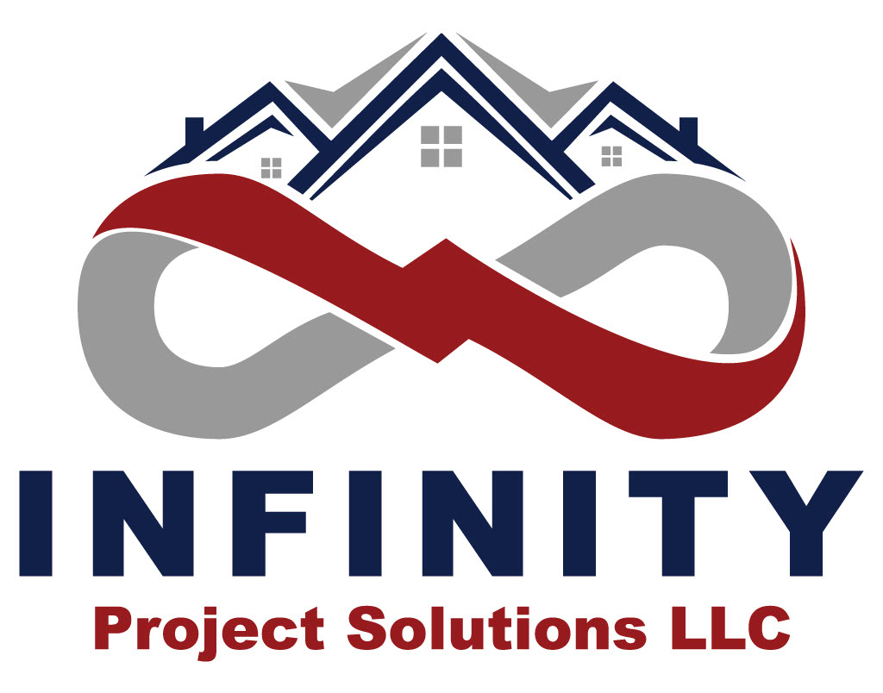
Phone: 409-519-9932
Email: InfinityPSLLC@gmail.com
Phone: 409-519-9932 Or 541-908-2527
Email: InfinityPSLLC@Gmail.com
Licensed & Bonded for all your important projects!
Commercial & Residential
- Flooring (Certified)
- Painting (Lead Certified)
- Drywall and more …..

Infinity Project Solutions LLC specializes in flooring installation of all types in the Willamette Valley, North Coast, Portland Metroplex, and some Southwestern regions. Our customers appreciate the quality of work they receive, we exceed in expectations, and we finish professionally every project within the quoted time.

Many of our customers contract Infinity through referrals from neighbors and past customers. Our customers have remarked on the friendly service they receive from our teams, the free estimates and the transparency throughout each project.

No job is too big or too small. Please call our office or email us to schedule your next flooring project estimate.

Infinity Project Solutions LLC Flooring department provides:

Hardwood/Engineered Hardwood Installs, Repairs, Custom Colors, Stains, Sand and finishes

Floor Leveling

Floor Restoration

Tiling

Laminate

LVP/LVT

Vinyl

Carpet

Carpet Tile

Rubber Base

Floor demolition

Infinity Project Solutions LLC Painting department provides:
Pressure Washing
Interior and Exterior Painting
Drywall repairs and Installation

Find Inspiration in Our Past Projects and Our Competitive Prices.

References upon request

PRICING:

-We take pride in being transperent and fair across the board to all of our clients and customers.

Flooring Price Guide:

Hardwood Installs Per SF $3.50 - $5.00
LVT/LVP Installs Per SF $2.00 - $2.50
Carpet Tile Install Per SY $5.50 - $6.50
Carpet Install Per SY $5.50 and Up Depending Materials

Sand & Finish Per SF $4.00 - $7.00
Underlayment Labor Per Sheet (4x8) $25 - $35

Painting Price Guide:

Contractor Paint included in most estimates. Price may vary depending on paint pricing.

$3.50-$4.25 Interior Paint * $3.25 - $4.25 Exterior Paint

Includes:
- General Preperations (caulking, sanding etc)
- One Coat of Primer (as needed)
- Two Coats Of Paint (as needed)

Prices are for labor only and subject to change

